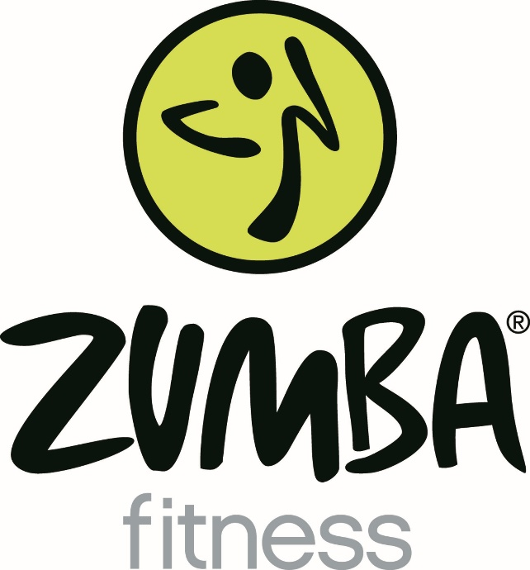

Most. Fun. Workout. Ever!
Music and movement will be kid-friendly for both guys and girls. For all ability and fitness levels. 6-ft distanced.

Thursdays @ 3:15-4:15 pm
$4/class, drop-in
Heidi Dean
Logic school teacher + Zumba-certified instructor

